**Installation:**

Go to the Manpe Eateries folder and Open the database named db_vrumao and copy all the queries. Open XAMPP and start the MySQL, type phpMyAdmin and run the selected queries in the SQL for the creation of the tables.

**For the session:** Refer the login page, login with the admin details to use the admin page and login with the customer details to view the customer page.

**URL to access my Website:**

https://300693.cdms.westernsydney.edu.au/~vrumao/Manpe%20Eateries/login.php

**\*\*\*\*\*\*\*\*\*\*\*\*\*\*\*\*\*\*\*\*\*\*\*\*\*\*\*\*\*\*\*\*\*\*\*\*\*\*\*\*\*\*\*\*\*\*\*\*\*\*\*\*\*\*\*\*\*\*\*\*\*\*\*\*\*\*\*\*\*\*\*\*\*\*\*\*\*\*\*\*\*\*Note: When the Customer creates an account, it is verified by the Admin in the Admin portal under the Users Section. If the User is not verified, he/she won’t be able to see the Past Orders. Also, due to security reasons I have added the Wallet options only for some number of Username just in case someone enters real number and the CVV. So, kindly select the Cash on Delivery when you order. Also, if you want to go by Wallet please use the below mentioned Username and Password.**

**Username: user1**

**Password: pass1**

**Also, for the admin login use the username and password as follows.**

**Username: root**

**Password: toor**

**********************************************************************************

**Project members:** My name is Viana Rumao and my student ID is 19928207.I have worked individually on this project, I didn’t have a team. I had a good experience developing the website sine I got to implement a lot of functions and the user interface.

**Purpose of the site:** The purpose of the website is to deliver and order food online via the website. The website is targeted for the age group of 20-50 since they usually tend to order food online. The user Interface is easy to navigate and gets you to the pages easily.

**Site usage:**



Login page: For the admin and user login to maintain the session from the time the user/ Admin logs in.

Also, any new user can register the first time she/he will be using the website.

For logout just click on the profile name.

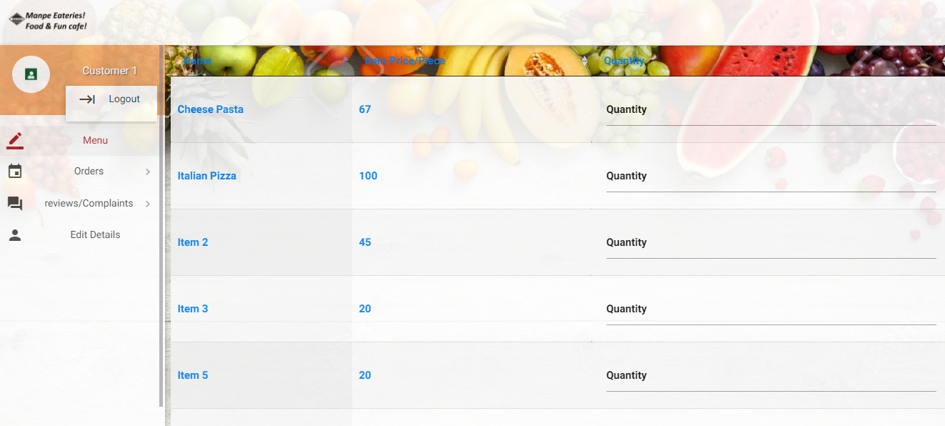

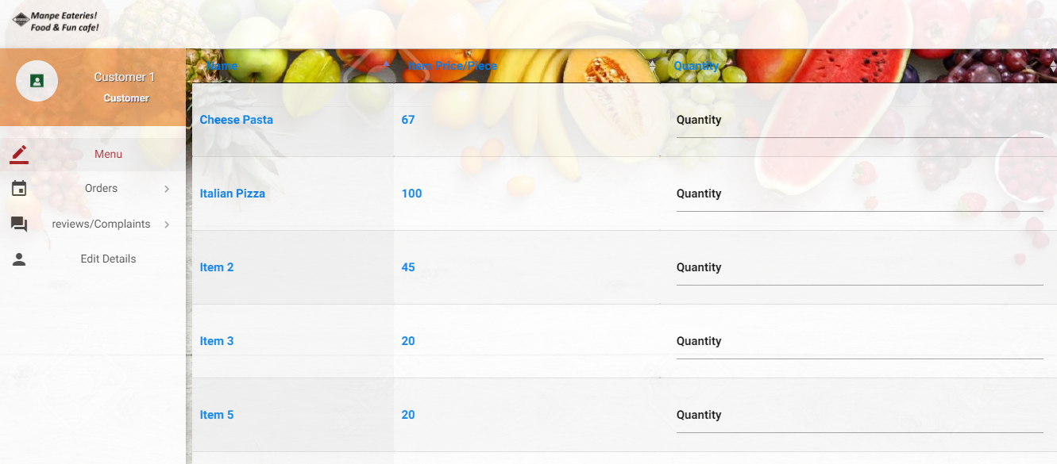

After the user/customer logs in it initiates to the page where the customer is able to order food and see the order and also give the ratings and the feedback and Edit the details of the user.

**\*\*\*\*\*\*\*\*\*\*\*\*\*\*\*\*\*\*\*\*\*\*\*\*\*\*\*\*\*\*\*\*\*\*\*\*\*\*\*\*\*\*\*\*\*\*\*\*\*\*\*\*\*\*\*\*\*\*\*\*\*\*\*\*\*\*\*\*\*\*\*\*\*\*\*\*\*\***

**Note: When the Customer creates an account, it is verified/authenticated by the Admin in the Admin portal under the Users Section. If the User is not verified, he/she won’t be able to see the Past Orders. Also, due to security reasons I have added the Wallet options only for some number of Users just in case someone enters real number and the CVV. So, kindly select the Cash on Delivery when you order.**

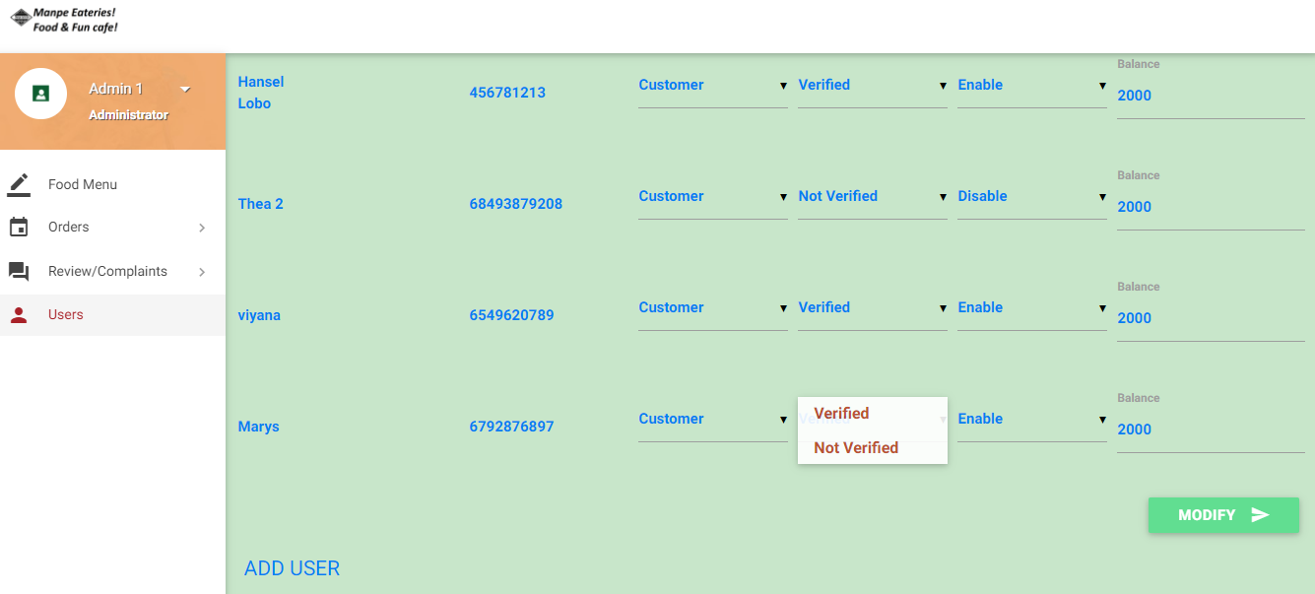

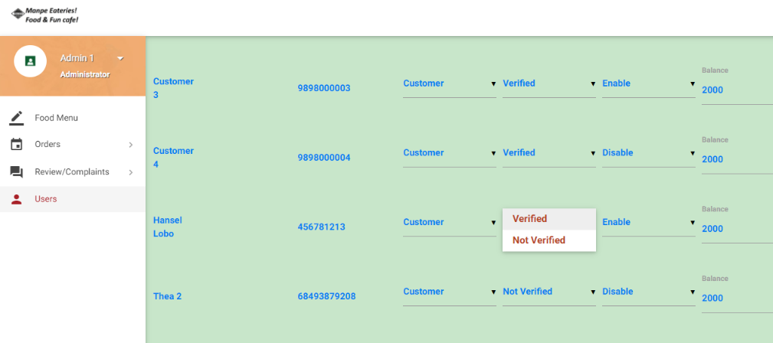

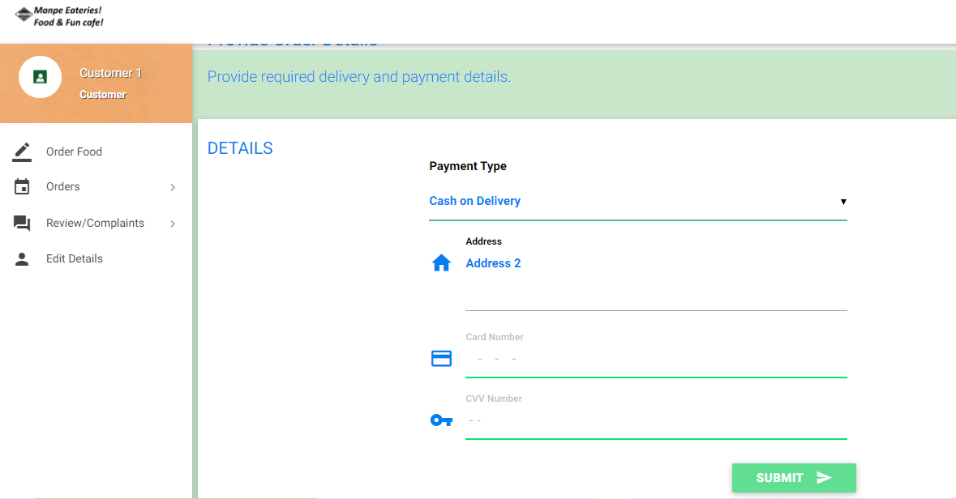

**********************************************************************************

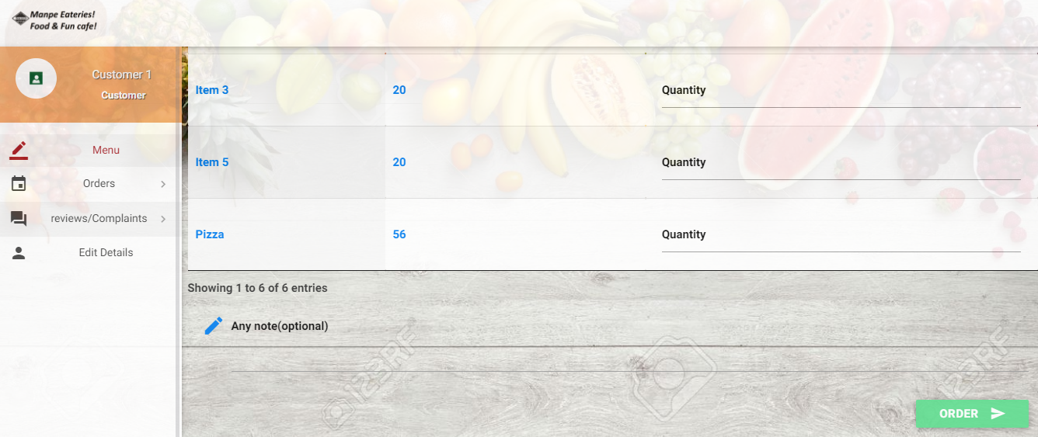

Any additional comment the user wants to add or specify can be done at the end.

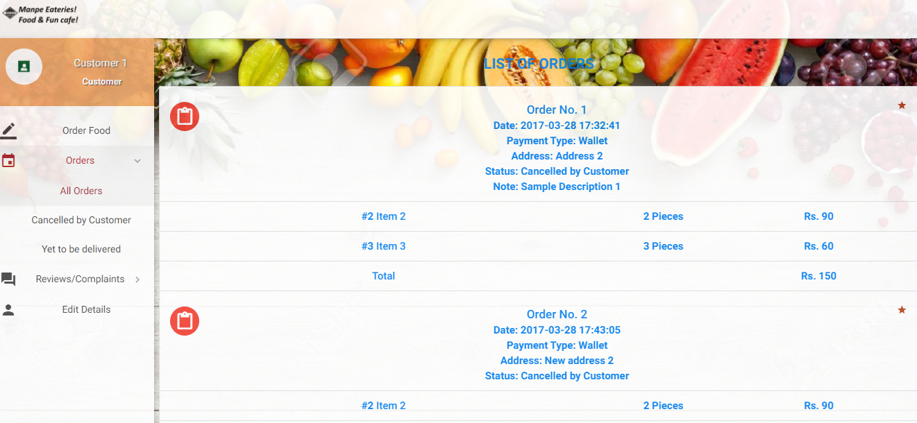

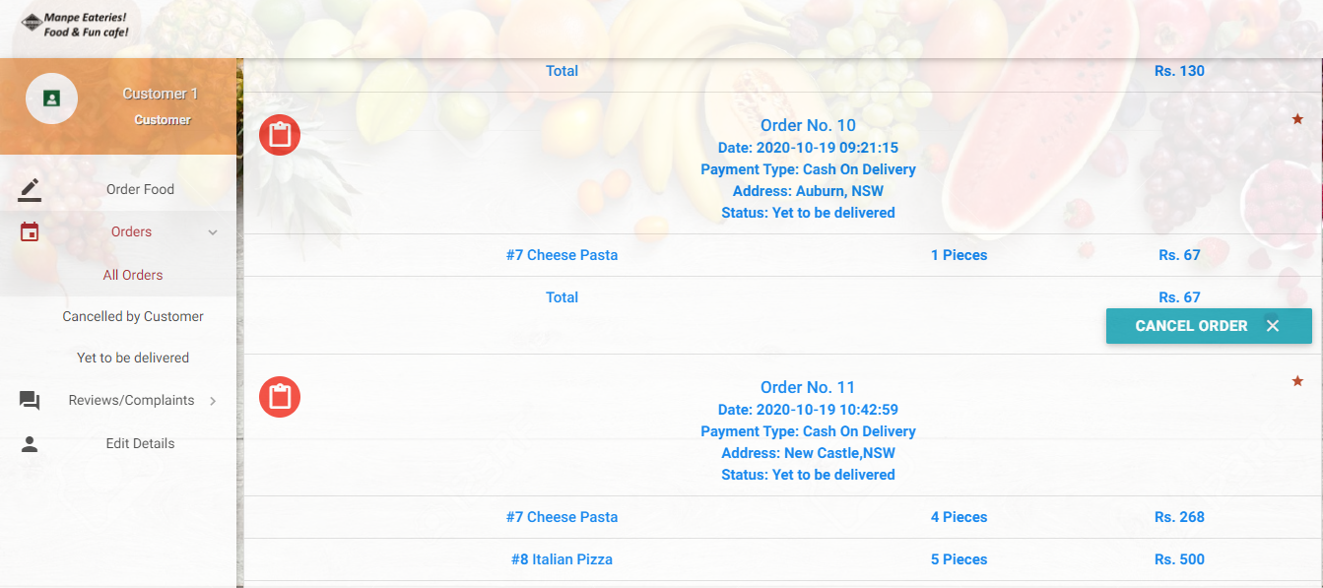

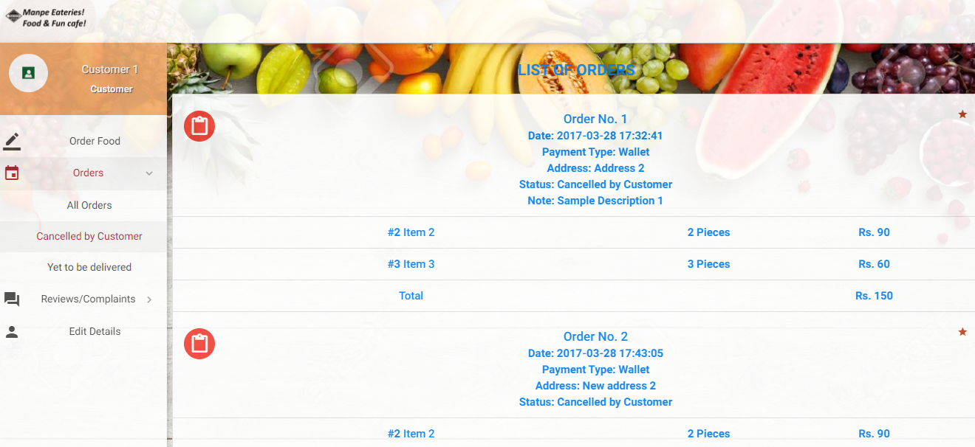

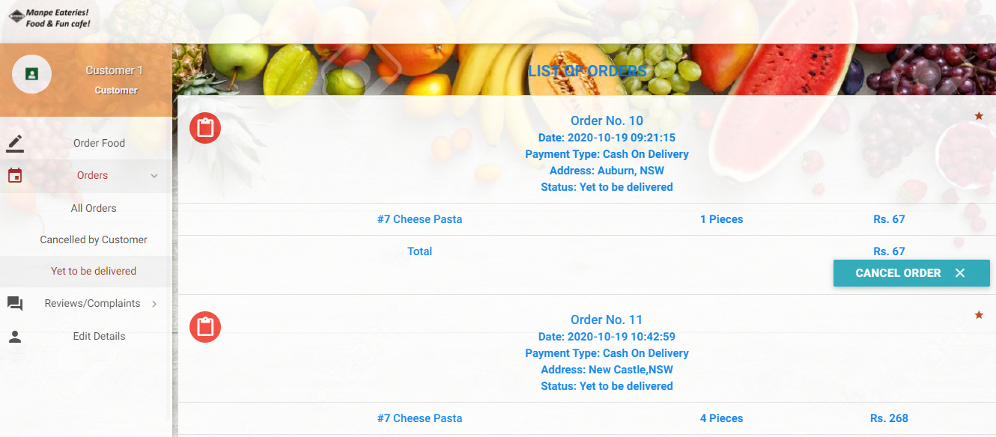

A list of all the orders of the customers can be seen in the orders section. The cancelled by customer section shows all the order cancelled by the customer. Also, the customer can cancel the order.

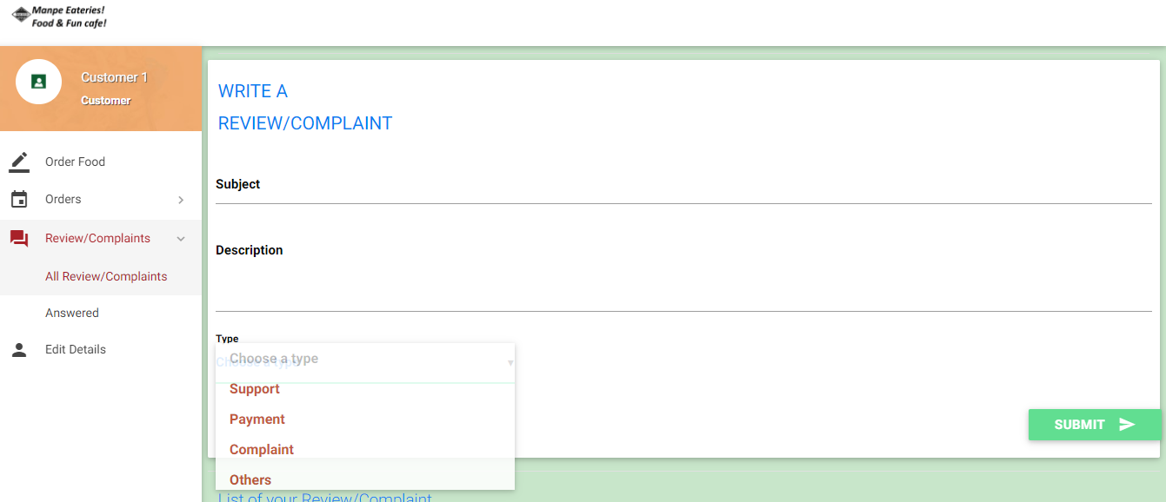

The user/customer also can give a review/ratings/feedback regarding anything be it support/payment/complaint or anything else.

The user can also see the list of the review/ratings/feedback that are done by them previously.

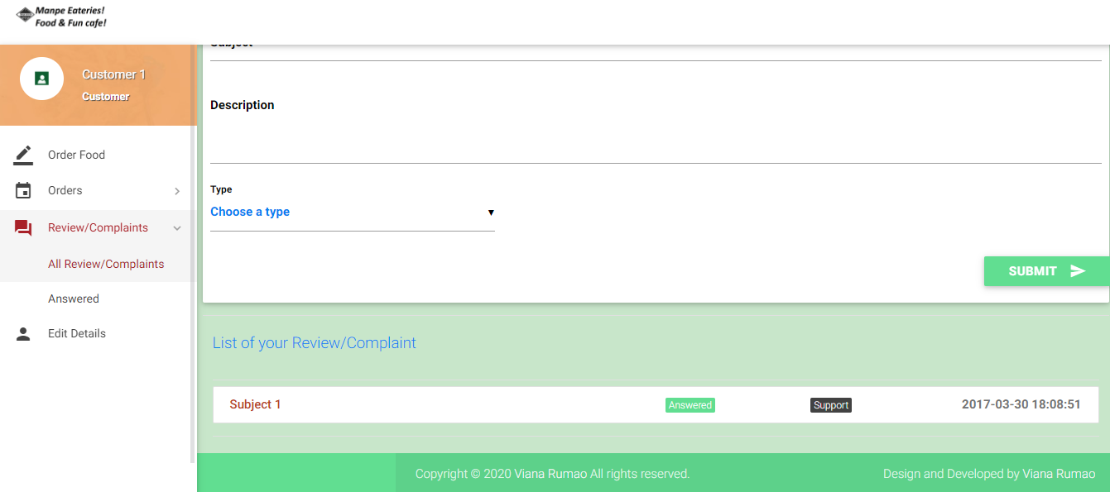

The user can edit their details as well in the edit section. Finally, when the customer hits the Profile name it provides a logout option wherein the user can logout and it takes to the login page.

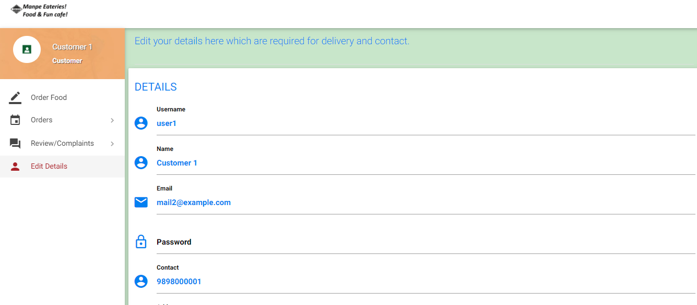

**Admin side:**

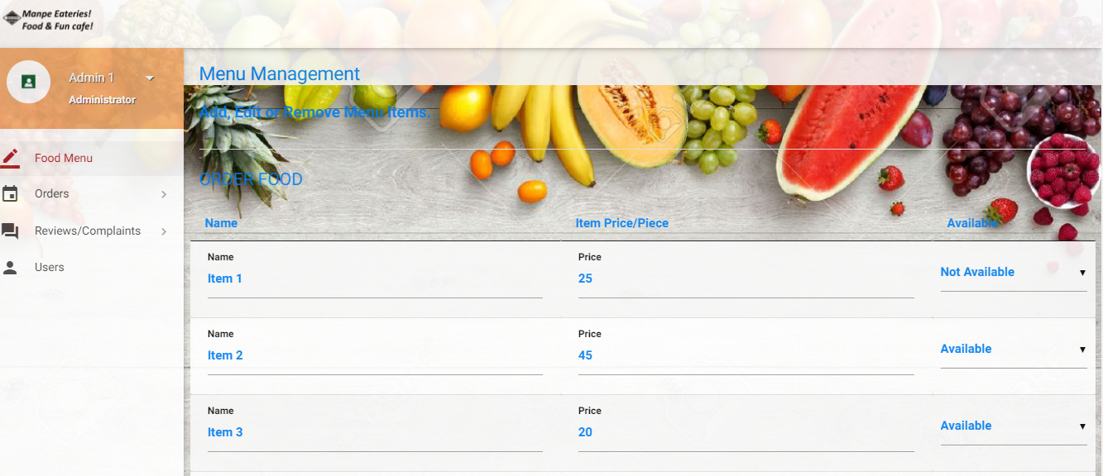

Once you login in using the admin details, it takes you to the frontend part wherein the admin can see the dashboard that has the food menu, Orders, past Reviews/Complaints and the users.

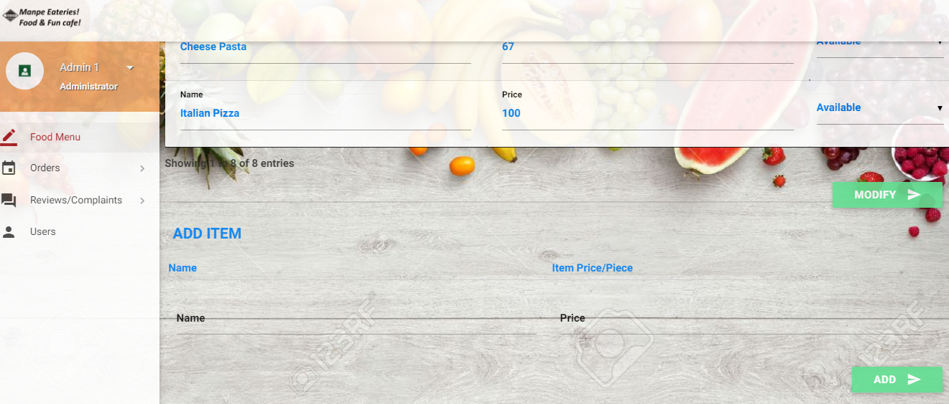

As seen if the admin hits the add button an item is added into the database and if he clicks the Modify button an item information is modified.

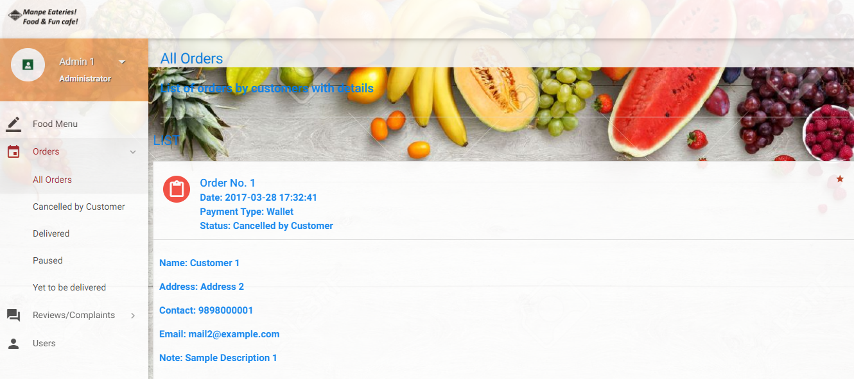

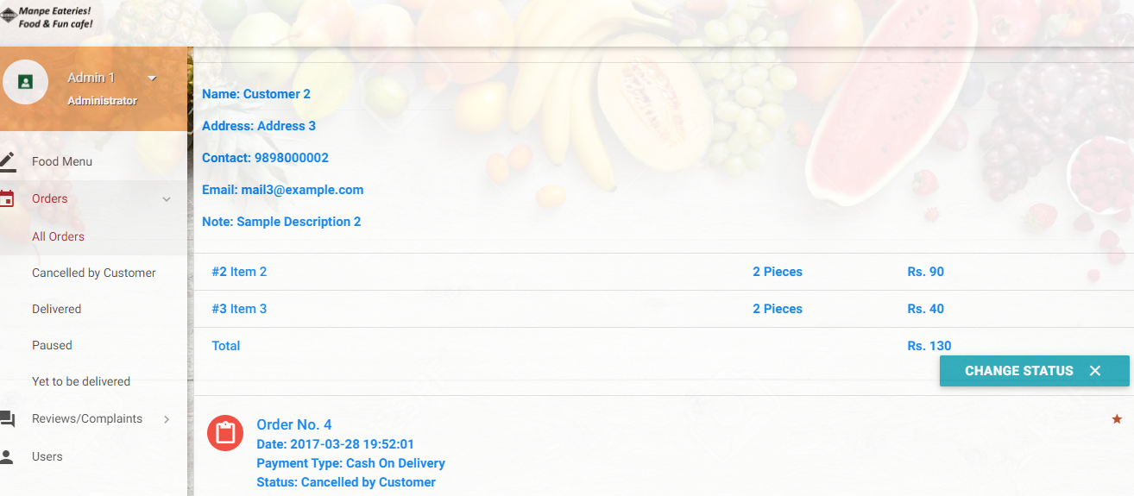

In the order section the admin Is able to see the Cancelled/Yet to be delivered/paused and all the orders. Also, the admin can change the status of the order whether is delivered or paused or cancelled.

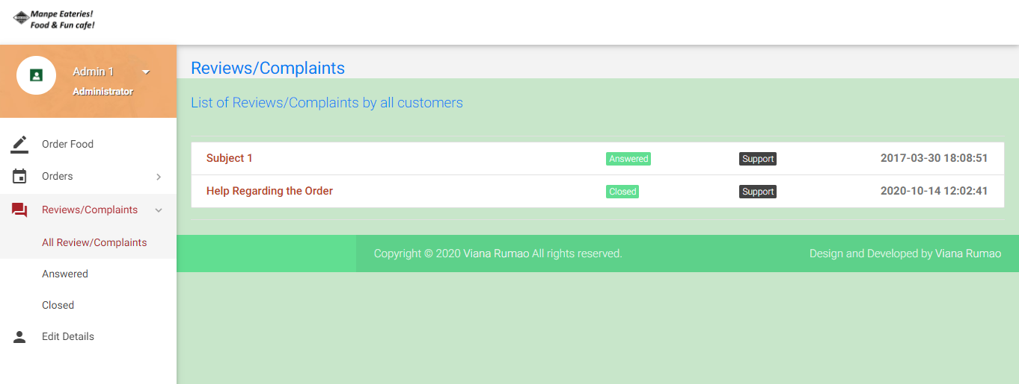

The admin can view the reviews/complaints by the user and can view/edit the status of the complaint.

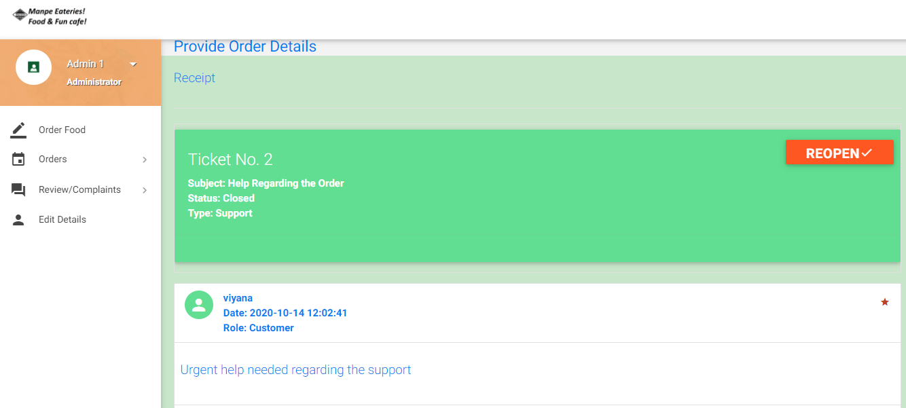

The details of the complaint can be seen if we click on the complaint.

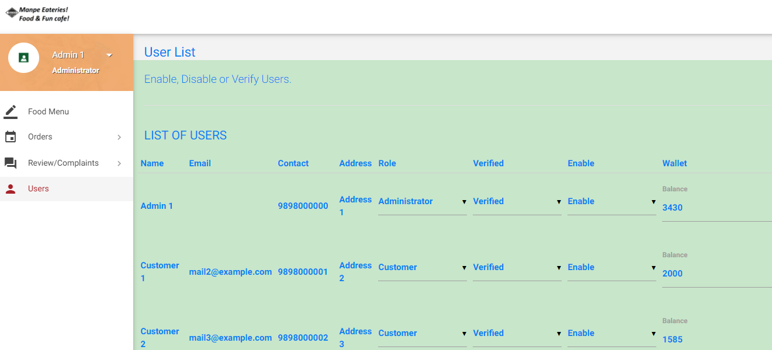

In the User section, the admin will be able to see all of the users and their details and will be able to modify/add a user in the database.

**Methodology:**

Design: Please refer to the above section Site Usage. It has detailed screenshots about the design.

Testing: Functional, Compatibility, Interface, Performance testing.

**Infrastructure and Platforms Required:** XAMPP, Text Editor, Browser

**Languages:** HTML, CSS, JAVASCRIPT, JQUERY, AJAX, PHP.

**Design Challenges:** The design challenges faced was to add a proper continuous navigation with having a responsiveness to the website. Also, designing the admin page was a bit challenging since there were a lot of functionalities that needed to be implemented in the page. To solve this, I did refer the lecture notes and Practicals some videos/tutorials on YouTube and also the Stack Over Flow And some other articles that helped me understand the procedure

In terms of the technical design and difficulty, coding for the backend and fetching the information from the backend by using PHP was a bit challenging. But I revisited my PHP concepts and also referred the Lectures/Tutorials and some online videos that helped me understand better.

**Technical Exploration:** AJAX stands for the Asynchronous and XML and it allows us to fetch content from the back-end server asynchronously without a page refresh. I have tried using AJAX with PHP in order to display the new order the customer places from the database tables without refreshing the page.

**Database Design:** The Database has 8 Tables.

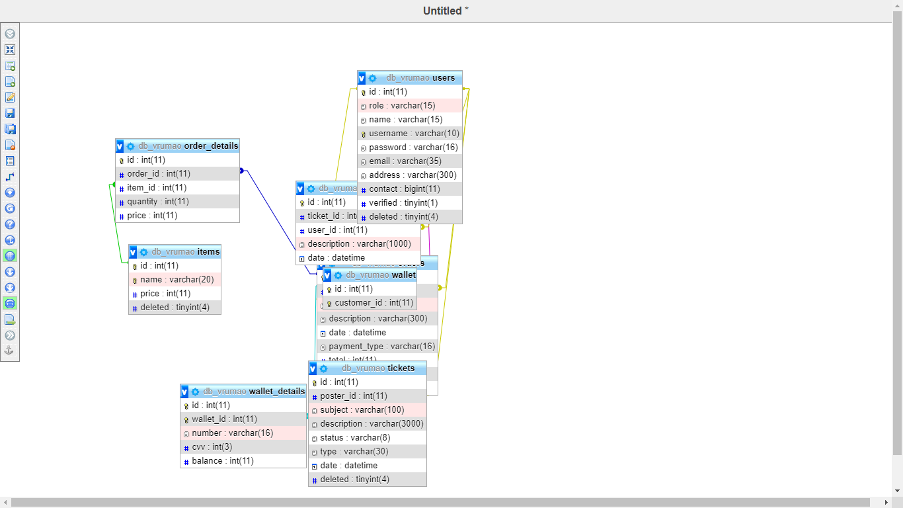

**Citations:** *PHP MySQL Scripts with tutorials and downloads*. (2000, February 5). Plus2net.Com. https://www.plus2net.com/php_tutorial/php-scripts.php

‌

user3552442. (2014, April 19). *Fetching data from MySQL database using PHP, Displaying it in a form for editing*. Stack Overflow. https://stackoverflow.com/questions/23174380/fetching-data-from-mysql-database-using-php-displaying-it-in-a-form-for-editing

‌

View all posts by Admin. (2019, October 3). *PHP Code Fetch Data from Database and Display in Table - Tuts Make*. Tuts Make. https://www.tutsmake.com/php-retrieve-or-fetch-data-from-mysql-database-and-display/

‌

*How to fetch data from Database in PHP and Display in Dropdown List?* (2019). 11zon.Com. https://www.11zon.com/zon/php/how-to-fetch-data-from-database-in-php-and-display-in-dropdown-list.php

‌

*How to fetch data from Database in PHP and Display in Dropdown List?* (2019). 11zon.Com. https://www.11zon.com/zon/php/how-to-fetch-data-from-database-in-php-and-display-in-dropdown-list.php

‌

*Creating a User Login System with PHP and MySQL - Tutorial Republic*. (2020). Tutorialrepublic.Com. https://www.tutorialrepublic.com/php-tutorial/php-mysql-login-system.php‌

*\*

*AJAX PHP*. (2020). W3schools.Com. https://www.w3schools.com/js/js_ajax_php.asp

‌

cullen, cindy. (2010, September 14). *How to Use PHP, JavaScript (or jQuery), and HTML Together - Cullen Web Services*. Cullen Web Services. <https://cullenwebservices.com/how-to-use-php-javascript-or-jquery-and-html-together/>

*W3Schools Online Web Tutorials*. (2020). W3schools.Com. https://www.w3schools.com/

‌